# Preface

lernOS is a self-management method for people living and working in the 21st century. To be successful today you have to learn, organize, and develop yourself on an ongoing basis. Nobody else is responsible for that process. You have to care for it on your own (self-directed lifelong learning).

If you decide to start with lernOS I suggest that you find 3-4 other people and become a peer support group called a learning circle. Let this document guide you to a 13 week experience called a learning sprint. Do a retrospective after the sprint and decide if you want to go on with another one. This can be with the same circle members or with new ones.

If you need support to find circle members you can ask your friends and network or use the free [Circlefinder App](http://circlefinder.app). If you have any further questions you can use the [lernOS category](https://community.cogneon.de/c/lernos) on [CONNECT](https://community.cogneon.de) or write with the [hashtag #lernOS on Twitter](https://twitter.com/search?q=%23lernOS). If you want to have an easy chat function for your circle you can use the personal messaging function on CONNECT and start a group chat.

The adoption of lernOS is a matter of months or years not hours or days. So Keep Calm & Learn On!

@simondueckert

# Acknowledgments

lernOS is inspired by many of sources and thought leaders and is thus [standing on the shoulders of giants](https://en.wikipedia.org/wiki/Standing_on_the_shoulders_of_giants). An overview of the inspirations I have compiled [in the Lernos Wiki](https://github.com/simondueckert/lernos/wiki) under Roots&Inspirations. I would like to especially thank Hirotaka Takeuchi and Ikujiro Nonake for introducing the term scrum for agile development in 1986. Jeff Sutherland and Ken Schwaber for creating the definition of scrum in [The Scrum Guide](https://scrumguides.org) and make it available under an open license. David Allen for the method [Getting Things Done](https://gettingthingsdone.com) (GTD) to show the path towards the art of stress-free productivity. Andy Grove for the development of the method [Objective & Key Results](https://en.wikipedia.org/wiki/OKR) (OKR) as a further development of Peter Drucker's management by objectives (MbO) at Intel in the 1980s. John Doer for bringing OKR to Google and Rick Klau from Google Ventures for his talk [How Google sets goals: OKRs](https://www.youtube.com/watch?v=mJB83EZtAjc). Glyn Moody (2006) and Bryce Williams (2010) for coining the term Working Out Loud and John Stepper for the design of the 12-week WOL learning program documented in the [WOL Circle Guides](https://workingoutloud.com/en/circle-guides). Katharina Krentz for her many contributions to make WOL and other methods usable in organizations to develop a learning organization.

# Introduction

We are facing enormous challenges driven by globalization, digitization, and a fast rate of technological and scientific progress. At the same time those changes provide us with a lot of new opportunities for development. The future is uncertain and we cannot predict it. So we need to be open and ready for it (Source: [Learning Framework 2030](http://www.oecd.org/education/2030)).

To navigate through the so called [VUCA](https://en.wikipedia.org/wiki/Volatility,_uncertainty,_complexity_and_ambiguity) world of the 21st century full of volatility, uncertainty, complexity, and ambiguity teenagers, students, professionals, managers, and leaders have to upskill themselves. Everybody has to develop skills like creativity, critical thinking, communication, and collaboration. Digital literacy is important to be able to use digital tools productively. The personal motivation for development should be more than getting a well-paid job or making profit. Everybody should care about the well-being of himself, his friend & families, his communities, and the society. We need to learn what knowledge, skills, mindset, attitudes, values, methods, and tools we need to design and shape a better future together.

lernOS can help you to get fit for the 21st century. lernOS is an operating system for livelong learning and learning organizations. The phrase “mi lernos” means “I will learn” in Esperanto. lernOS helps to organize the daily, weekly, and monthly activities and to learn consciously from every action. It will also promote networking with other people so you don’t have to reinvent every wheel and repeat every mistake.

And the best thing is: lernOS is free, open, and easy to understand. Start using it today!

# lernOS Wheel: New Mindset, Skillset, and Toolset

Mastering the VUCA world of the 21st century requires to be open for change and new approaches. There are a lot of tools and methods out there. But when one is not open to give it a try, experiment, and fail there will be no success. Like the people with the “square wheels” in the image below we are often too busy to see new opportunities.

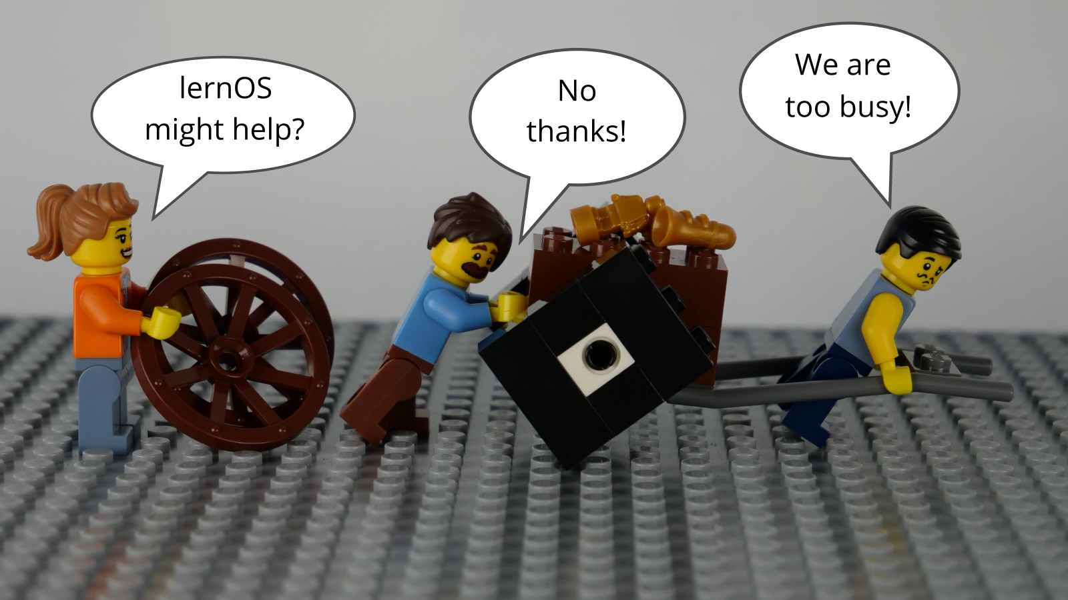

lernOS Wheel People by @simondueckert, CC BY 4.0

Adopting new practices in life, school, or work is not only about using digital tools. To switch from “square wheels” to “round wheels” the personal attitude, values, and skills have also to be taken into account. lernOS calls these three dimensions mindset, skillset, and toolset. To focus only on some dimensions might help. But for the best results all three should be considered in the personal development process.

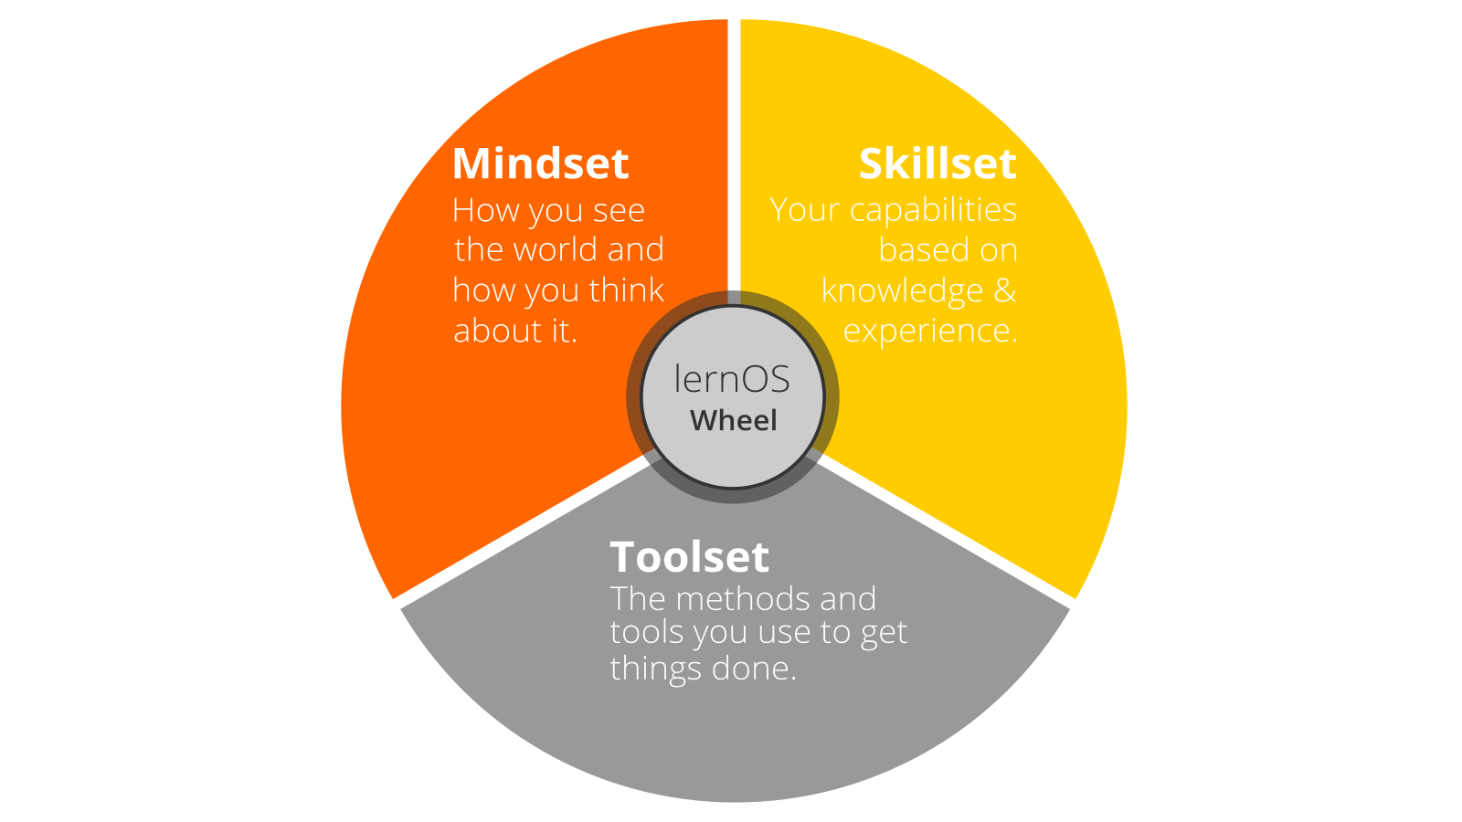

lernOS Wheel by @simondueckert, CC BY 4.0

## Mindset: Your World View

The mindset can be described as the attitudes and values that lead to actions and visible results. These values develop over time and form the culture of organizations and society. When we act in the world we get feedback and learn from it. Over time our mind creates mental models of the world and values that guide our future actions ([Boisot, 2004](http://www.rrojasdatabank.info/thermo/20388.pdf)). To successfully navigate the VUCA world these five values are important to be successful (Buhse 2014 & Petry, 2014):

1. **NETWORKING** over isolation
2. **TRUST** over suspiciousness
3. **OPENNESS** over silos
4. **PARTICIPATION** over exclusion
5. **AGILITY** over stability

There is no ranking in the values above but for some people [openness](https://en.wikipedia.org/wiki/Openness) seems to be the core value for a 21st century mindset. It means being open to new experiences, knowledge, and ideas as well as sharing knowledge, ideas, and content openly (see also the [Open Definition](https://opendefinition.org)). You should develop an “open first mindset” over time as described in the [Open First Manifesto](http://innovationsbeirat.de/open-first):



Open First (innovationsbeirat.de/open-first) by innovationsbeirat, CC BY SA 4.0

**#ProTip:** your mindset is not fixed it can grow over time. Watch Carol Dweck’s video on [Developing a Growth Mindset](https://www.youtube.com/watch?v=hiiEeMN7vbQ) to learn more about it.

## Skillset: Your Capabilities

Since the 1980s skills like solving problems and interacting with others in creative ways became most important to be successful. These are also skills that can’t be easily replaced by automation and artificial intelligence in the future. To get fit for the 21st century you have to train the following skills ([Framework for 21st Century Learning](http://www.p21.org/our-work/p21-framework), [DigiComp 2.1 Framework](https://ec.europa.eu/jrc/en/publication/eur-scientific-and-technical-research-reports/digcomp-21-digital-competence-framework-citizens-eight-proficiency-levels-and-examples-use)):

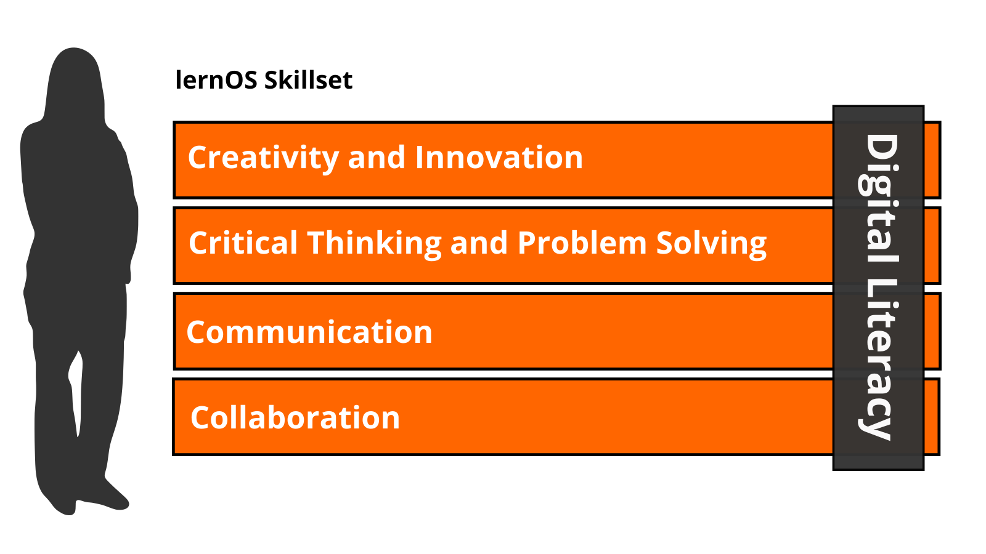

lernOS Skillset by @simondueckert, CC BY 4.0

|  |  |
| --- | --- |
| Skill Area | Skill |
| **Creativity and Innovation** | Think creatively |
|  | Work creatively with others |
|  | Implement innovations |
| **Critical Thinking And Problem Solving** | Identifying needs and technological responses |
|  | Reason effectively |
|  | Make judgments and decisions |
|  | Solve technical and non-technical problems |
|  | Creatively using technologies to solve problems |
| **Communication** | Articulate thoughts and ideas clearly and effectively |
|  | Listen effectively to decipher meaning |
|  | Use communication to inform, instruct, motivate and persuade |
|  | Utilize multiple media and technologies |
|  | Communicate effectively in diverse environments |
| **Collaboration** | Work effectively and respectfully with diverse teams |
|  | Exercise flexibility and willingness to be helpful in making necessary compromises to accomplish a common goal |
|  | Assume shared responsibility for collaborative work, and value the individual contributions |
|  | Interacting, engaging, sharing, and collaborating through digital technologies |
|  | Managing digital identity |
| **Digital Literacy** | Browsing, searching, filtering data, information and digital content |
|  | Evaluating and managing data, information and digital content |
|  | Protecting digital devices, personal data and privacy |
|  | Developing, integrating, and re-elaborating digital content |
|  | Handling Copyright and licences |
|  | Programming, Scripting, and Coding |

**#ProTip:** the Mozilla Foundation has developed the [Web Literacy Framework](https://learning.mozilla.org/en-US/web-literacy) with a lot of exercises for developing digital literacy and 21st century skills.

## Toolset: Digital Tools You Use

With the emergence of [Web 2.0](https://www.oreilly.com/pub/a/web2/archive/what-is-web-20.html) in 2005 social media entered the stage. Not everybody needs to know all the tools but you should have an overview, know the principles, and choose the right tools for yourself. The [conversation prism](https://conversationprism.com) gives a nice overview of web 2.0 platforms available today:



Conversation Prism 5.0 (conversationprism.com) by Brian Solis and JESS3

For a beginner 28 categories and dozens of tools might be overwhelming. Therefore the following list provides an overview of the most relevant tools for learnOS:

1. **Office & Productivity**, e.g. Dropbox, Evernote, Freemind, G Suite, MindManager, Office 365, OneNote, SharePoint, Trello, XMind
2. **Chat & Messenger**, e.g. Google Hangouts Chat, Mattermost, Microsoft Teams, RocketChat, Slack, Telegram, Threema, WeChat, WhatsApp
3. **Social Networks**, e.g. IBM Connections, Jive, LinkedIn, Mastodon, Twitter, Workplace by Facebook, Xing, Yammer
4. **Videoconference**, e.g. Google Hangouts Meet, GoToMeeting, Microsoft Teams, Skype, Skype for Business, WebEx, Zoom
5. **Weblogs & Wikis**, e.g. Confluence, DokuWiki, LinkedIn (Article), MediaWiki, Medium, tumblr, Wikipedia, Wordpress

**#ProTip:** the [lernOS Wiki](https://github.com/simondueckert/lernos/wiki) contains a list with links to all the mentioned tools. There will be tutorials on how to use them in the future.

# lernOS Canvas: Structure Your Thinking Visually

A canvas is a visual structure that can be used to work through several building blocks in a systematic way. This way you use a canvas as a visual checklist. It can also be used to tell a complex story. The idea came from Alex Osterwalder who invented the [business model canvas](https://en.wikipedia.org/wiki/Business_Model_Canvas). The lernOS Canvas uses the same basic structure as the business model canvas. But the names of the building blocks have been changed to reflect the topics a circle works on during a sprint.

The lernOS Canvas can be downloaded from the [lernOS Website](https://lernos.org) in different formats (e.g. PowerPoint, PDF, PNG). To be able to work with the canvas in an agile way one should NEVER write on a canvas … that’s why sticky notes were invented!

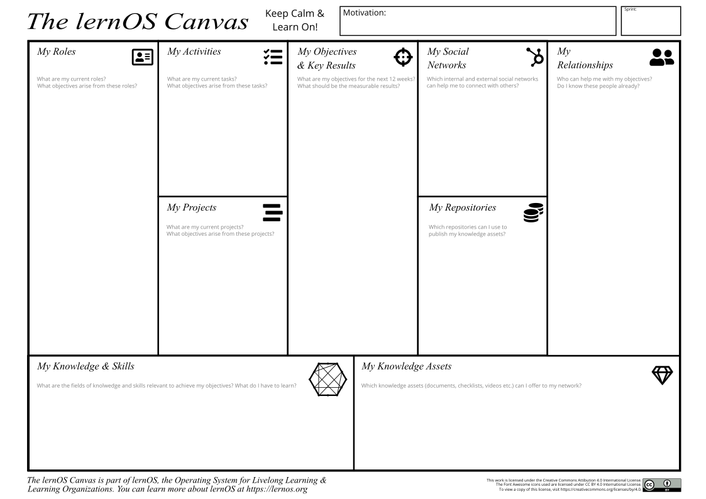

lernOS Canvas by @simondueckert, CC BY 4.0

The header of the canvas contains the creation date, the number of the sprint, and a motivation/mission statement (if you have one). In the building block “My Objectives & Key Results” the goals for the current sprint are documented. The building blocks “My Roles”, “My Activities”, “My Projects”, and “My Knowledge & Skills” can be used to identify potential objectives. “My Relationships” and “My Social Networks” can be used to identify people that can help you to achieve your objectives. Available resources (e.g. documents, checklists, videos etc.) are listed in “My Knowledge Assets”. The repositories listed at “My Repositories” can be used to share assets generously with the network. All exercises that can be documented in the canvas are indicated by “lernOS Canvas: …” in the kata description.

**#ProTip:** if you use the lernOS OneNote Circle Template you can take a photo of the current version of the canvas and upload so the other circle members can see it and give feedback.

# Learning Sprint: A 13 Week Self Learning Experience

lernOS is practiced in timeboxes of 13 weeks called learning sprints. Normally sprints run along the quarters of a year but the rhythm can be changed if necessary. The week 0 is used for the planning of the sprint. From week 1-11 a learning path suggests exercises called katas to learn something new. In week 12 a retrospective is done to reflect on the learnings.

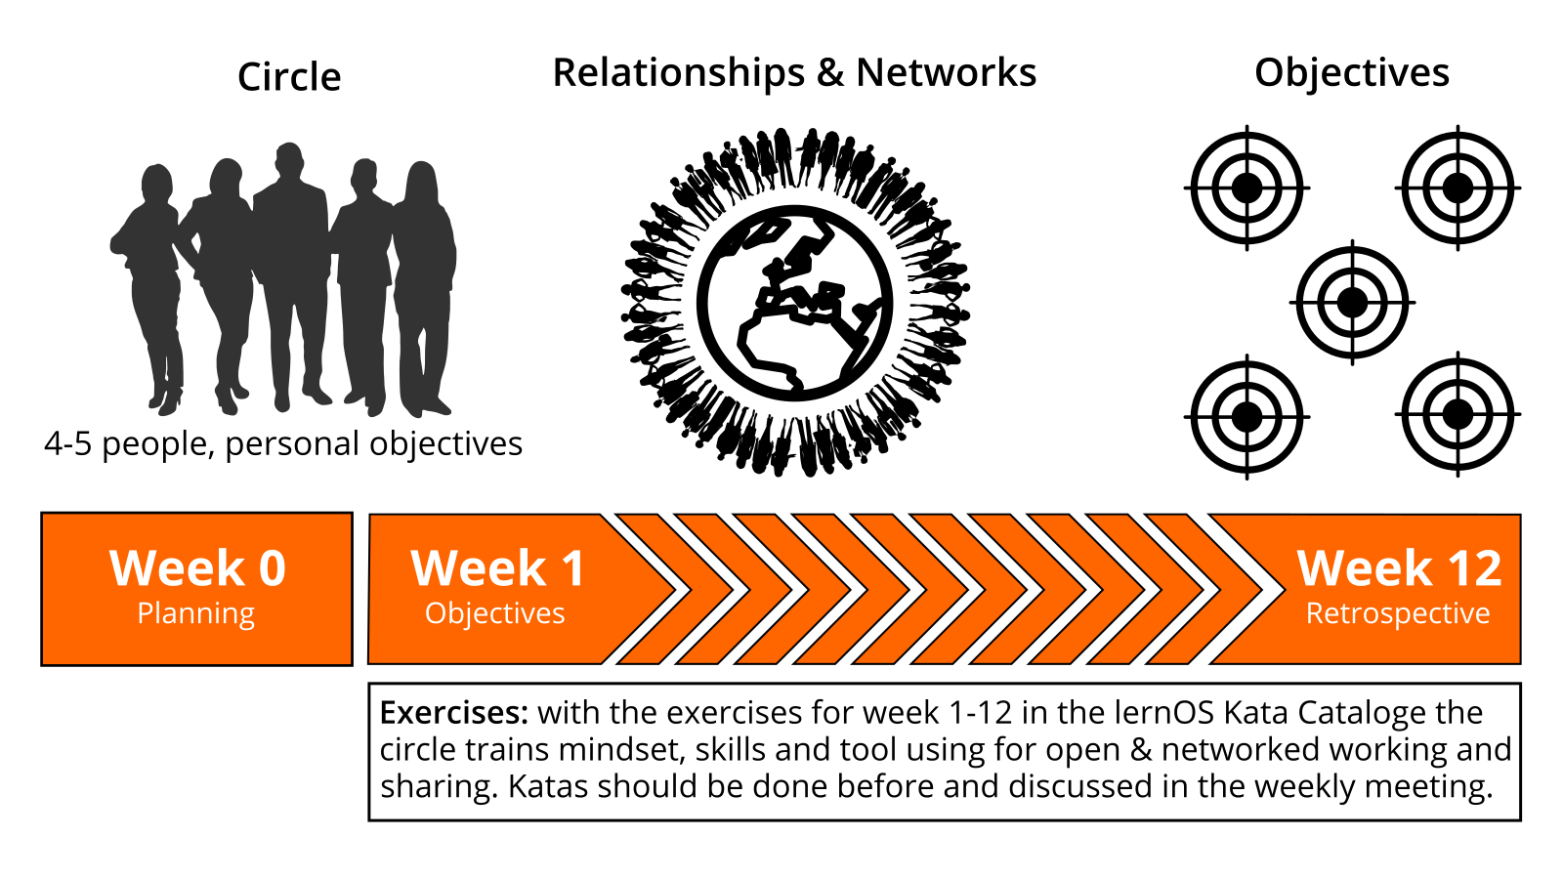

lernOS Sprint by @simondueckert, CC BY 4.0

This is what happens during a learning sprint:

* **Week 0 with the Sprint Planning:** Does everybody understand the process? When will the weekly meeting be? Will the weekly be face-to-face or virtual? Which tools are used for communication and documentation? Is everybody able to use the tools?
* **Weeks 1-11 with the Weekly Meeting:** the circle members are working on their objectives and desired results during the sprint. A learning path provide the circle members with a set of exercises called katas to build a network that supports them with achieving their objectives. The two pitstops in week 4 and week 8 help to see if everybody is still on track.
* **Week 12 with the Retrospective:** the circle members show their final results and reflect on the overall process. They also decide if they want to do another sprint together.

# Learning Circle: The Power Of Peer Support

If you do not want to practice lernOS on your own you can do it in a group of 4-5 people called a learning circle. A circle is a [peer support](https://en.wikipedia.org/wiki/Peer_support) group in which members help each other with feedback, experience, knowledge, and reflection. The circle is a circle of trust: what happens in the circle stays in the circle! The circle members will have a weekly meeting with a standard agenda to structure the learning and development process.

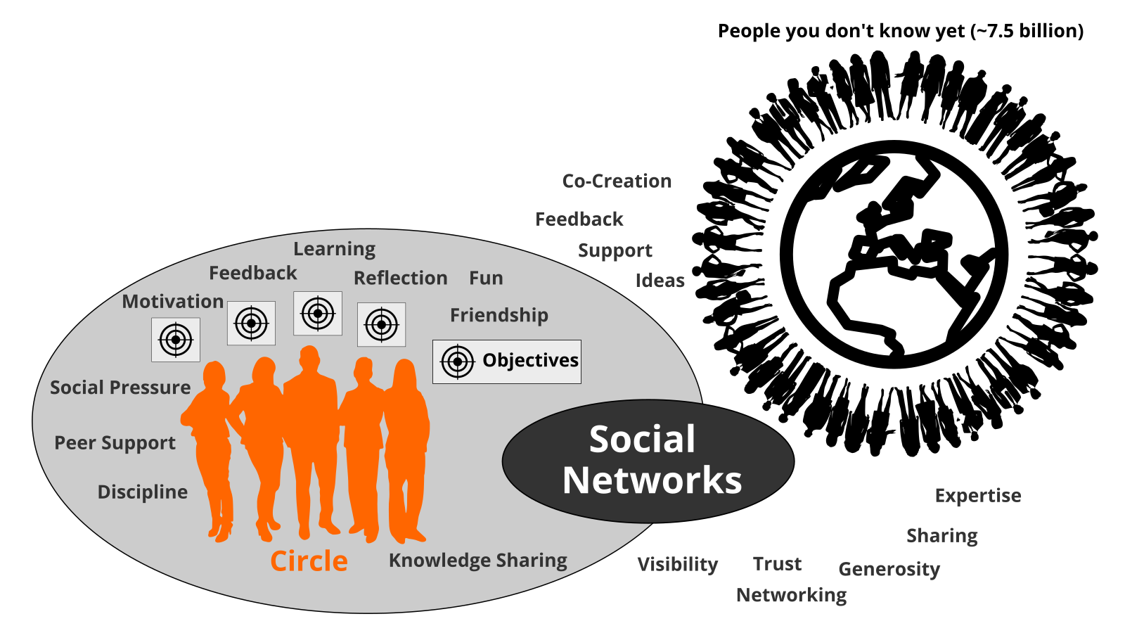

Learning Circle by @simondueckert, CC BY 4.0

A learning circle meets once a week. Each meeting has a standardized agenda with a check-in, suggested exercises called lernOS Katas (see appendix for the weekly agendas and the exercise descriptions), and a check-out. The timebox for the weekly can be adopted to the needs of the circle members, suggested timeslot is Friday between 11-12am.

**#ProTip:** Kata is just another term for exercise. It comes from practicing programming skills in a peer learning format. Read more about this format at [codekata.com](http://codekata.com).

The weekly meeting can be face-to-face or virtual. The circle has to define tools for communication and documentation between the meetings. The following table suggests tools that have proven to work in practice:

|  |  |  |
| --- | --- | --- |
| Tool A-Z | Communication | Documentation |
| Enterprise Social Network (ESN),e.g. IBM Connections, Jive, Yammer | **X** | **X** |
| appear.in | X |  |
| E-mail | X |  |
| Evernote |  | X |
| Facebook Group | **X** | **X** |
| Facebook Messenger | X |  |
| Google Doc |  | X |
| Google Hangout | X |  |
| GoToMeeting | X |  |
| Jitsi | X |  |
| Microsoft Teams | **X** | **X** |
| Skype | X |  |
| Slack | X |  |
| Telegram | X |  |
| Threema | X |  |
| WebEx | X |  |
| WeChat | X |  |
| WhatsApp | X |  |
| Zoom | X |  |

**#ProTip:** To have a good usability choose a tool that supports communication and documentation, e.g. a [Facebook Group](https://www.facebook.com/help/1629740080681586) or [Microsoft Teams](https://products.office.com/en-us/microsoft-teams/group-chat-software). In a Facebook Group you can use the activity stream for communicating and [group docs](https://www.facebook.com/help/203003559734725) for documentation. In Microsoft Teams you can use the channel “General” for communication and wiki pages or a OneNote Notebook for documentation.

# NOOB Path: The Sprint for lernOS Beginners

A learning path is a set of activities and exercises to learn something new. A path can last for one or more sprints. The NOOB Path is a sprint for practitioners who want to break down their silos and adopt a new style of working and living that is open and connected. The NOOB Path consists of 11 Katas (exercises) to learn how to reach a goal with the help of a network. It is suggested to do the path with 4-5 people in a single sprint.

**Note:** the idea for this sprint is inspired by John Stepper’s [Working Out Loud circle method](https://workingoutloud.com/en/circle-guides) (WOL). Due to own experience in 12 WOL circles and a WOL circle survey ran in 2018 the number of exercises have been reduced to 11 to fit more easy in the 13 weeks without loosing aspects of the core idea of WOL.

## Circle Moderator Checklist

### Week 0: Sprint Planning & Get Together

When you are new to the circle you will get to know each other in week 0. You will plan when to meet, which tools to use and who is the moderator is.

* **Check-in:** Welcome Everybody! *(5 minutes)*
* **Get together:** Who are you? Introduce yourself. Five minute timebox per Circle member. *(25 minutes)*
* **Sprint Planning** see below *(25 minutes)*
* **Check-out:** Confirm the next meeting. *(5 minutes)*

Define a circle moderator who cares for event and time management. The moderator is not the “boss” of the circle but just a normal member that cares for smooth operation. Define the day and time of your weekly circle meeting. Define if you meet face-to-face or virtually . Define the tools you use for communication and documentation in the circle. Decide which exercises from the suggested agenda you plan to do in the circle. Also decide if you want to use the lernOS Canvas (see chapter lernOS Canvas) as supporting tool.

* **Circle moderator:** …
* **Day & time of weekly meeting:** …
* **Weekly meetings are:** face-to-face / virtual
* **Tools used in circle:** …
* **Do we use the Canvas:** yes / no

**#ProTip:** in a lot of circles the timebox for running an exercise in the Weekly is too short. You should use the method [inverted classroom](https://en.wikipedia.org/wiki/Flipped_classroom). Every circle member prepares the exercises as “homework” upfront so you will have more time to discuss results in the circle.

### Week 1: My Objective For The Next 12 Weeks

In this week you choose your objective for the sprint. The objective might be refined until week 4 but not later.

* **Check-in:** What happened since the last check-in? What changed in the key results? What is slowing me down? Two minute timebox per circle member. *(10 minutes)*
* **Kata:** My Objective For The Next 12 weeks *(45 minutes)*
* **Check-out:** What will I do until the next Weekly? One minute timebox per circle member. *(5 minutes)*

### Week 2: People Related To Your Objective

In this week you will start to think about people who might help you with your objectives (Working alone is addition, working together is multiplication!).

* **Check-in:** What happened since the last check-in? What changed in the key results? What is slowing me down? Two minute timebox per circle member. *(10 minutes)*
* **Kata:** People Related To Your Objective *(45 minutes)*
* **Check-out:** What will I do until the next Weekly? One minute timebox per circle member. *(5 minutes)*

### Week 3: Your First Sharing Experience

In this week you start to share attention, knowledge, experiences, and assets with your network to build trust and get support.

* **Check-in:** What happened since the last check-in? What changed in the key results? What is slowing me down? Two minute timebox per circle member. *(10 minutes)*
* **Kata:** Your First Sharing Experience *(45 minutes)*
* **Check-out:** What will I do until the next Weekly? One minute timebox per circle member. *(5 minutes)*

### Week 4: An Appointment With Yourself & Pitstop 1

In this week you will make sure that you have enough time for networking, sharing, and caring for your network. You will do this by making appointments with yourself. In this week your objectives should be stable and you should have a clear idea which people in the network might help you to get your things done. Take this week for a short “pitstop” to reflect if everything works well for you and the circle. The next four weeks you will focus to work on the first iteration of your key results.

* **Check-in:** What happened since the last check-in? What changed in the key results? What is slowing me down? Two minute timebox per circle member. *(10 minutes)*
* **Kata:** An Appointment With Yourself *(45 minutes)*
* **Check-out:** What will I do until the next Weekly? One minute timebox per circle member. *(5 minutes)*

### Week 5: Go Google Yourself!

In this week the work on the first iteration of your key results should have started. The goal is to have a [minimum viable product](https://en.wikipedia.org/wiki/Minimum_viable_product) (something that works and that you can show) by the end of week 8. In this week you will also look yourself up in the intranet or internet.

* **Check-in:** What happened since the last check-in? What changed in the key results? What is slowing me down? Two minute timebox per circle member. *(10 minutes)*
* **Kata:** Go Google Yourself! *(45 minutes)*
* **Check-out:** What will I do until the next Weekly? One minute timebox per circle member. *(5 minutes)*

### Week 6: 25 Facts About Me

In this week you will collect facts and personal information that might be relevant for your network and help you to connect.

* **Check-in:** What happened since the last check-in? What changed in the key results? What is slowing me down? Two minute timebox per circle member. *(10 minutes)*
* **Kata:** 25 Facts About Me *(45 minutes)*
* **Check-out:** What will I do until the next Weekly? One minute timebox per circle member. *(5 minutes)*

### Week 7: Your Top 10 Assets

In this week you will work on finishing the first iteration of your minimum viable product. In addition you will reflect on your top 10 knowledge assets that you can share in your network.

* **Check-in:** What happened since the last check-in? What changed in the key results? What is slowing me down? Two minute timebox per circle member. *(10 minutes)*
* **Kata:** Your Top 10 Assets *(45 minutes)*
* **Check-out:** What will I do until the next Weekly? One minute timebox per circle member. *(5 minutes)*

### Week 8: Update Your Digital Twin & Pitstop 2

In this week the first iteration of your key results should be available. Talk about them and show them in the check-in. If your digital twins like website, blog or profile do not match your findings from last week you will go out and update them.

* **Check-in:** What happened since the last check-in? What changed in the key results? What is slowing me down? Two minute timebox per circle member. *(10 minutes)*
* **Kata:** Update Your Digital Twin *(45 minutes)*
* **Check-out:** What will I do until the next Weekly? One minute timebox per circle member. *(5 minutes)*

### Week 9: Find Communities Related To Your Objective

In this week you will start working on the second iteration of your key results. In addition you will look for communities or groups that can help you to reach your objectives.

* **Check-in:** What happened since the last check-in? What changed in the key results? What is slowing me down? Two minute timebox per circle member. *(10 minutes)*
* **Kata:** Find Communities Related To Your Objective *(45 minutes)*
* **Check-out:** What will I do until the next Weekly? One minute timebox per circle member. *(5 minutes)*

### Week 10: Contribute Your Self

In this wee you will use the facts about yourself to make a personal connection. And you will learn that sometimes listening is more important then talking.

* **Check-in:** What happened since the last check-in? What changed in the key results? What is slowing me down? Two minute timebox per circle member. *(10 minutes)*
* **Kata:** Contribute Your Self *(45 minutes)*
* **Check-out:** What will I do until the next Weekly? One minute timebox per circle member. *(5 minutes)*

### Week 11: Write A Letter To Your Future Self

In this week you will start to envision yourself in the future by writing a letter to your future self. And you will help your network to support you by making your vision and your objectives visible on your online profiles.

* **Check-in:** What happened since the last check-in? What changed in the key results? What is slowing me down? Two minute timebox per circle member. *(10 minutes)*
* **Kata:** Write A Letter To Your Future Self *(45 minutes)*
* **Check-out:** What will I do until the next Weekly? One minute timebox per circle member. *(5 minutes)*

### Week 12: Retrospective & Celebration

In this week the final iteration of your key results should be available. Talk about them and show them in the check-in. You will reflect on the circle experience and talk about how to sustain the process. After the weekly you should take some time to celebrate your success!

* **Check-in:** What happened since the last check-in? Show the final iteration of the key results. 3 minute timebox per circle member. *(15 minutes)*
* **Your Learning Moments:** Talk about the moments in the sprint that where special for your. What are your key learnings? *(20 minutes)*
* **After Action Review:** What was the plan for the sprint? What did happened? Is there any deviation? What can you learn from it? *(20 minutes)*
* **Check-out:** Are there any next steps? Will you stay together for another sprint?
* **Celebration time!** *(timebox is up to you)*

## Kata: My Objective For The Next 12 weeks

What do you want to accomplish in the next 12 weeks? Pick an objective that you really, really care about and you can make progress towards in the sprint. You will use Google’s OKR method to define that objective. For the NOOB path it’s not prio 1 to achieve the objective. Core is to learn how to achieve objectives more easy with the help of an open workstyle and the development of a network.

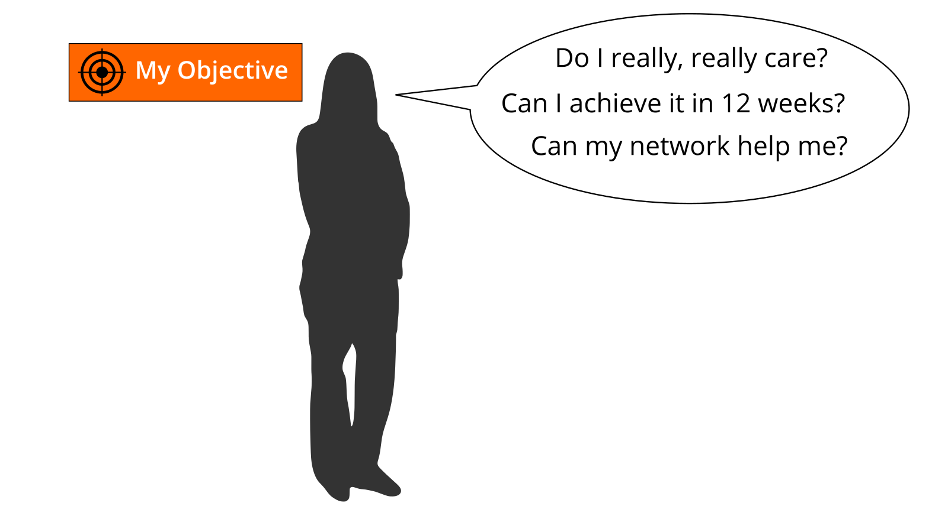

My Objectives For The Next 12 weeks

**Exercise (25 minutes):**

Select an objective for the next 12 weeks. Use the questions “Do I really, really care?”, “Can I achieve it in 12 weeks?”, and “Can my network help me?” to test if the objective is appropriate for the sprint. If you have problems to find a good objective think about goals that support your roles, activities, or projects. If you want to help to make the world a better place you can also choose an objective that is related to the [United Nation’s 17 sustainable development goals](https://www.un.org/sustainabledevelopment/sustainable-development-goals).

Use the principles from objective & key results (OKR) to specify your objective. Define an objective and write it down below. To help you to track progress define 2-4 key results per objective. You should be able to measure the key results on a scale from 0.0-1.0. To make sure to set yourself ambitious goals a completion rate of 0.7 is regarded as a success.

*I will (objective):* …

*as measured by (key results):*

1. …
2. …
3. …
4. …

Share your objective(s) in the circle (10 minutes).

**lernOS Canvas:** put objectives in the building block “My Objectives”. You might add further sticky notes for the key results as well.

**Further Information:**

* Wikipedia Article [SMART Criteria](https://en.wikipedia.org/wiki/SMART_criteria)
* MIT Sloan Article [With Goals, FAST Beats SMART](https://sloanreview.mit.edu/article/with-goals-fast-beats-smart)
* TED Talk [How We Can Make the World a Better Place by 2030](https://www.youtube.com/watch?v=o08ykAqLOxk)
* Video [How Google Sets Goals: OKRs](https://www.youtube.com/watch?v=mJB83EZtAjc) with Google ventures partner Rick Klau
* Book [Introduction To OKRs](https://www.oreilly.com/business/free/files/introduction-to-okrs.pdf) by Christina Wodtke
* Book [The Beginner’s Guide To OKR](https://felipecastro.com/resource/The-Beginners-Guide-to-OKR.pdf) by Felipe Castro

## Kata: People Related To Your Objective

Most tasks we do have been done by others before. Most of the mistakes we make, have been made in the past already. You can gain access to knowledge and experiences related to your objectives by getting in touch with experienced people inside and outside your organization. Strong relationships are based on trust, sharing, and caring. [Dale Carnegie](https://en.wikipedia.org/wiki/Dale_Carnegie) said “You can make more friends in two months by becoming interested in other people than you can in two years by trying to get other people interested in you”. So how do you get in touch with people related to your objectives and develop the relationship?

**Exercise (20 minutes):**

Create a list of at least ten people related to your objectives. If you don’t know people by name you can also put roles or descriptions on the list (e.g. “best WoW player in wown”, “a good camera man”, “owner of company XY”). Use your contact lists or social networks find more people:

1. …
2. …
3. …
4. …
5. …
6. …
7. …
8. …
9. …
10. …

Share your list in the circle and let others help to complete it (10 minutes).

**lernOS Canvas:** collect people related to your objective in the building block “My Relationships”. You can sort them by priority if you like.

**Further Information:**

* Video [Social Networking In Plain English](https://www.youtube.com/watch?v=6a_KF7TYKVc)

## Kata: Your First Sharing Experience

Sharing is caring! In the digital world sharing is often seen as giving others access to files or digital content. But it can also be as simple as sharing your attention with another person by following him, liking his content or subscribing to his website. By sharing you deepen your relationships with every contribution you make.

**Exercise (40 minutes):**

Go through your relationship list and look for some kind of online presence for each person (e.g. website, blog, profile in social network). Look for possibilities to share some attention. This might be a follow button, a like button, a subscribe field, a five star rating, a comment field or a contact form. Make at least five sharing experiences:

1. …
2. …
3. …
4. …
5. …

Discuss your sharing experiences in the circle (20 minutes).

**lernOS Canvas:** if you find people from your relationship list inside a social network list the network in the building block “My Social Networks”.

## Kata: An Appointment With Yourself

Do you spend enough time for your personal development and for working on your personal objectives? A lot of people are busy with their daily tasks and do not care enough for their development and their well-being. A good approach is to make an appointment with yourself and reserve that time for yourself in the calendar.

**Exercise (15 minutes):**

Check your calendar and see when an appointment with yourself fits in. One hour or even 30 minutes a week is a good starting point. Put an appointment with yourself in the calendar. If possible make it a recurring event so taking time for yourself can become a habit. Make at least five appointments:

1. …
2. …
3. …
4. …
5. …

Discuss your approaches in the circle.

## Kata: Go Google Yourself!

What do people see when they search for you online? Do they get an idea of who you are and how they might help you with your objectives? You can simulate that situation by googling yourself (often called egosurfing, egosearching or vanity search).



Go Google Yourself on google.com or in an intranet search engine

**Exercise (10 minutes):**

Open a search engine in the internet or intranet and enter your name. Open at least the first 10 search results and check if your personality and the facts about you are up-to-date. Identify possible improvements:

1. …
2. …
3. …
4. …
5. …
6. …
7. …
8. …
9. …
10. …

Think about what your main online profile might be (e.g. LinkedIn profile, about.me profile or profile in your enterprise social network). This will be called your “digital twin”:

*My main online profile (digital twin) is …*

**lernOS Canvas:** add social networks you find profiles of yourself in the building block “My Social Networks”.

**Further Information:**

* Wikipedia Article [Egosurfing](https://en.wikipedia.org/wiki/Egosurfing)
* Article [Google Yourself! Measuring the performance of personalized information resources](http://snurb.info/files/aoir2008/Google%20Yourself!%20Measuring%20the%20performance%20of%20personalized%20information%20resources%20%28AoIR%202008%29.pdf) by Thomas Nicolai and Lars Kirchhoff.

## Kata: 25 Facts About Me

What are interesting facts about you that might help to connect with other people? If you apply to study at Fuqua Business School you have to write an essay with a list of 25 random things about yourself so the application team gets to know you better. When you write down facts about yourself you collect information that might help you to make new connections based on similar interests and backgrounds (e.g. “We studied in the same place 20 years ago!”). Random things about yourself might include:

* Life experiences
* Your likes/dislikes
* Where you were born/lived
* Family, kids, parents
* Schools, universities
* Workplaces in the past
* Career challenges
* Vacations
* Hobbies
* Achievements
* Fun facts
* Anything that helps to understand what makes you who YOU are

**Exercise (25 minutes):**

Create a list of 10 random facts about yourself. Then read the [Fuqua 25 random things do’s and dont’s](https://stratusadmissionscounseling.com/duke-fuqua-25-random-things-dos-donts) and expand your list to 25 things:

1. …
2. …
3. …
4. …
5. …
6. …
7. …
8. …
9. …
10. …
11. …
12. …
13. …
14. …
15. …
16. …
17. …
18. …
19. …
20. …
21. …
22. …
23. …
24. …
25. …

Share the facts about you in the circle (10 minutes).

**lernOS Canvas:** If any of the facts indicate knowledge domains or skills put them in the building block “My Knowledge & Skills”.

**Further Information:**

* YouTube-Search [“random facts about me”](https://www.youtube.com/results?search_query=random+facts+about+me)

## Kata: Your Top 10 Assets

What are the most valuable resources related to your objectives that you can share? A resource could be a book, a video, a link, a document, a checklist, a presentation etc. When you organize your resources in a way that they are linkable and shareble it will be easy for you to contribute them to your network.

**Exercise (30 minutes):**

Chose one of your objectives and list at least ten related resources you find useful or interesting:

1. …
2. …
3. …
4. …
5. …
6. …
7. …
8. …
9. …
10. …

Present the top 10 list in the circle and discuss it (10 minutes).

**lernOS Canvas:** collect the valuable assets related to your objectives in the building block “My Knowledge Assets”.

## Kata: Update Your Digital Twin

Does your main digital twin represent you in the way you want to? A lot of people register for an account in a social network and never think about updating their profile. You should keep your profile up to date and have a look at it on a regular basis (e.g. have a recurring task every three month). The facts about you, current projects and interests should be visible on that profile.

**Exercise (20 minutes):**

Check in the online profile if you have a nice image, a short description, and a slogan. List the improvements you want to make:

1. …
2. …
3. …
4. …
5. …
6. …
7. …
8. …
9. …
10. …

**lernOS Canvas:** mark the social network that contains your main online profile in the building block “My Social Networks”.

## Kata: Find Communities Related To Your Objectives

A tribe [according to Seth Godin](https://www.ted.com/talks/seth_godin_on_the_tribes_we_lead) is a group of people connected to one another, connected to a leader, and connected to an idea. Instead of tribe the term “community” or “community of practice” is also often used. A group needs only two things to be a tribe: a shared interest and a way to communicate. Tribes need leadership. Sometimes one person leads, sometimes more. Which are the communities related to your objectives?

**Exercise (15 minutes):**

Look for communities that are related to your objectives and find at least 10 (use e.g. [LinkedIn Groups](https://www.linkedin.com/groups), [Facebook Groups](https://www.facebook.com/groups), [Xing Groups](https://www.xing.com/communities) , [meetup.com](https://www.meetup.com), [reddit.com](https://www.reddit.com/reddits)):

1. …
2. …
3. …
4. …
5. …
6. …
7. …
8. …
9. …
10. …

Talk about your lists in the circle and let the others help you to complete your list.

## Kata: Contribute Your Self

Not all contributions in your network have to be about your objectives. Sometimes it’s good to share something about yourself to make a personal connection. The list of facts about yourself might help to find interesting links to other people. Try to find these possible links and use them to make a connection.

**Exercise (20 minutes):**

Go through your facts about you and find at least one fact that might be of interest for a person on your relationship list. Write a message to that person and try to deepen the relationship with that fact as a contribution:

1. …

## Kata: Write A Letter To Your Future Self

The letter to your future self is a classic method in self motivation and visioning. You reflect on your current situation and give your future self an advice. You write it down as a letter, address it to yourself and open it in the future. With the letter in the back of your mind chances are that your wishes become a [self-fulfilling prophecy](https://en.wikipedia.org/wiki/Self-fulfilling_prophecy).

**Exercise (35 minutes):**

Write a letter to your future self. Talk about who you are now (e.g. summary, fears, values, beliefs, skills, abilities, goals, hopes). Then address your future self with the things you want to stop/continue/start doing. Give yourself advice and ask yourself questions. Seal the letter and store it in a safe place or use services like [futureme.org](https://futureme.org) to send it to your future self automatically:



If you want to share the letter with your circle members just read it out loud afterwards (15 minutes).

**Further Information:**

* Video [A Letter To My Future Self](https://www.youtube.com/watch?v=XwN0tJlXF-0)
* Article [How to Write a Letter to Your Future Self](https://www.wikihow.com/Write-a-Letter-to-Your-Future-Self)

# Stop talking, start doing!

If you read through this guide but are not practising yet you should do so NOW! To start with lernOS is really easy. These five steps will help to start smoothly:

1. **Schedule Time:** define the quarter when you begin to use lernOS. Add the time-slots for the weekly to your calendar. This regular meeting is of particular importance if you practice in a lernOS Circle.
2. **Define Objectives and Key Results:** use week 0 to define the objectives and the measurable results for the sprint. Choose an objective you really, really care about.
3. **Find a Circle:** look for 3-4 people who want to start a sprint in the same quarter. If someone has been in a circle before he can take the role of the “Circle Moderator”.
4. **Organize the Weekly Meeting:** if you don’t know each other meet face-to-face in week 0. Use social networks or instant messengers to communicate between the meetings. Use video conferencing tools to organize virtual meetings.
5. **Plan, Do, Learn, Repeat:** Use the last weekly meeting in week 12 to reflect the results and the collaboration in the circle. Decide if you want to run another sprint together.

Keep Calm & Learn On! :-)

# Change History

|  |  |  |  |
| --- | --- | --- | --- |
| Version | Bearbeitet von | Beschreibung Änderung | Datum |
| 1.0 | Simon Dueckert | First Version of the lernOS Guide | 2018-09-17 |
| 1.0.1 | Simon Dueckert | Acknowledgement chapter added | 2018-09-17 |
| 1.1 | Simon Dueckert | OKRs als Standard-Methode für Learning Sprints, Einführung NOOB Path mit reduziertem Kata-Set, Umbenennung lernOS Sprint/Circle, Einführung von Lernpfaden | 2018-12-17 |
| 1.2 | Simon Dueckert | Guideline renamed to “lernOS Guide for You”, lernOS logo added to cover page, Telegram User Group replaced by CONNECT, Mobi version (Amazon) added to output formats, generation of all output files via make.bat, Table of Contents (TOC) added to html version | 2019-03-25 |